**Name of the Institute: Department of Transfusion Medicine**

**FACILITY & CLINICAL CARE**

|  |  |
| --- | --- |
| **Name of the existing facility:** | |
| **1** | **LABORATORY SERVICE** |
|  | * Blood Grouping * Cross - Coomb’s Matching Test * Direct Agglutination Test (DAT) * Indirect Agglutination Test (IAT) * Antibody Screening and Identification Test |
| **2** | **SPECIALIZED BLOOD COMPONENTS** |
|  | * Packed Red Cells (PRBC) * Fresh Frozen Plasma (FFP) * Random Donor Platelets (RDP) * Cryoprecipitate * Apheresis * Single Donor Platelets * Peripheral Blood Stem Cell Collection |
| **3** | **REGIONAL TESTING CENTRE** |
|  | * Advanced Immunohematology Workup * Antibody Titre, Autoimmune hemolytic anemia workup * Adsorption and Elution Testing * DTT Testing IgG Antibody Titre * Specific Red Cell Antigen Typing * Complete Red Cell Antigen Profile for Sickle cell anaemia/Thalassemia disease |
| **4** | **COAGULATION PARAMETERS- for quality control of blood components** |
| **5** | **THROMBOELASTOMETRY ANALYSIS BY USING ROTEM-for patient blood management for critical cases & liver transplant cases** |
| **6** | **AUTOMATED COMPONENT EXTRACTOR -for preparing buffy coat platelets** |
| **7** | **HLA- NGS (Low Resolution/High resolution- Single Bead Antigen assay, donor specific antigen workup** |
| **8** | **CLIA -Chemiluminescence immunoassay- for TTI screening** |
| **9** | **ANTIBODY TITRE -for Pre& Post Renal Transplant cases** |
| **10** | **LEUKOREDUCTION - of blood products** |
| **11** | **STEM CELLS - cryopreservation & thawing** |

**PRE DONATION COUNSELLING**

**DONOR PHLEBOTOMY**

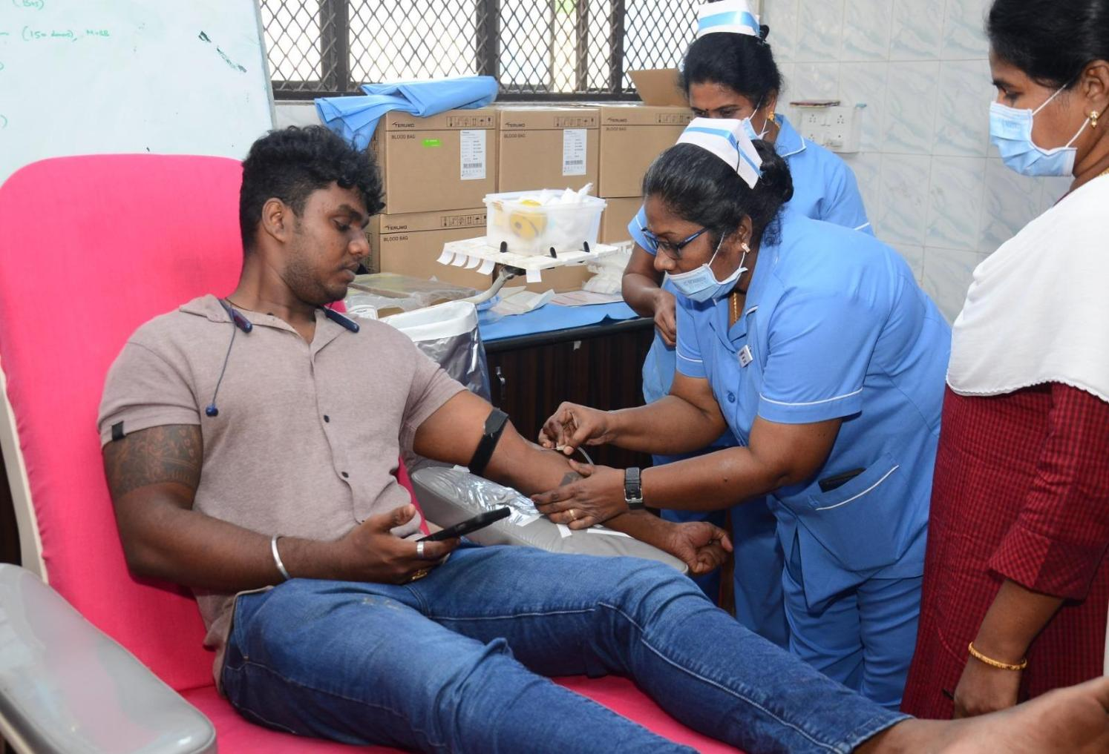

**ROTEM**

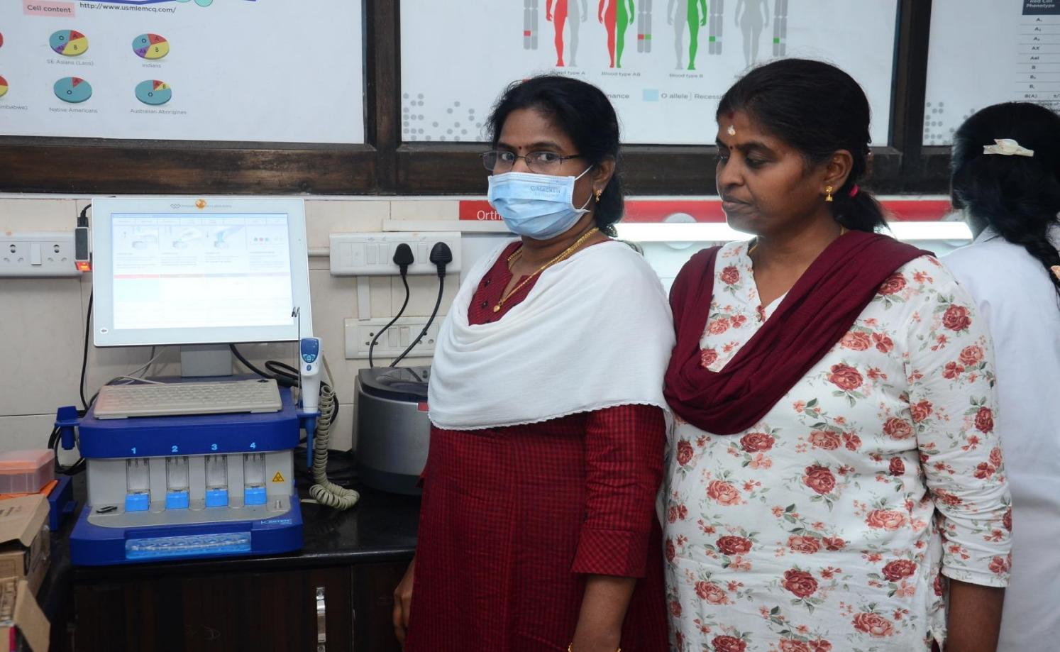

**CROSSMATCHING**

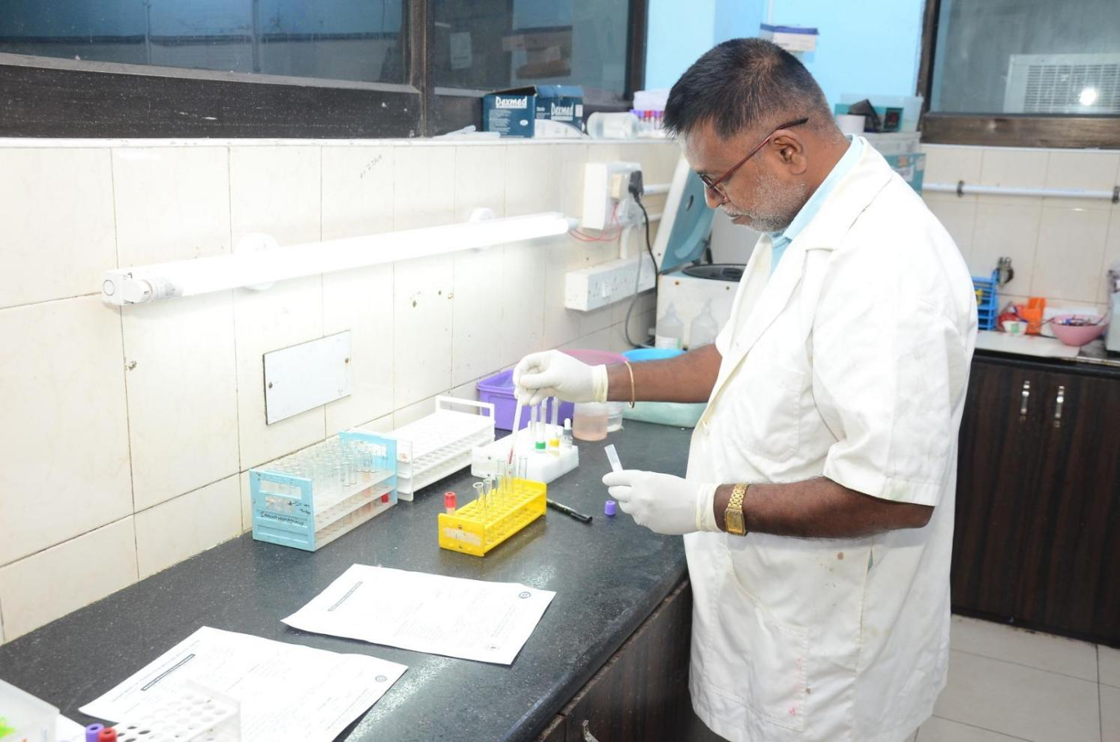

**BLOOD COMPONENTS ISSUE**

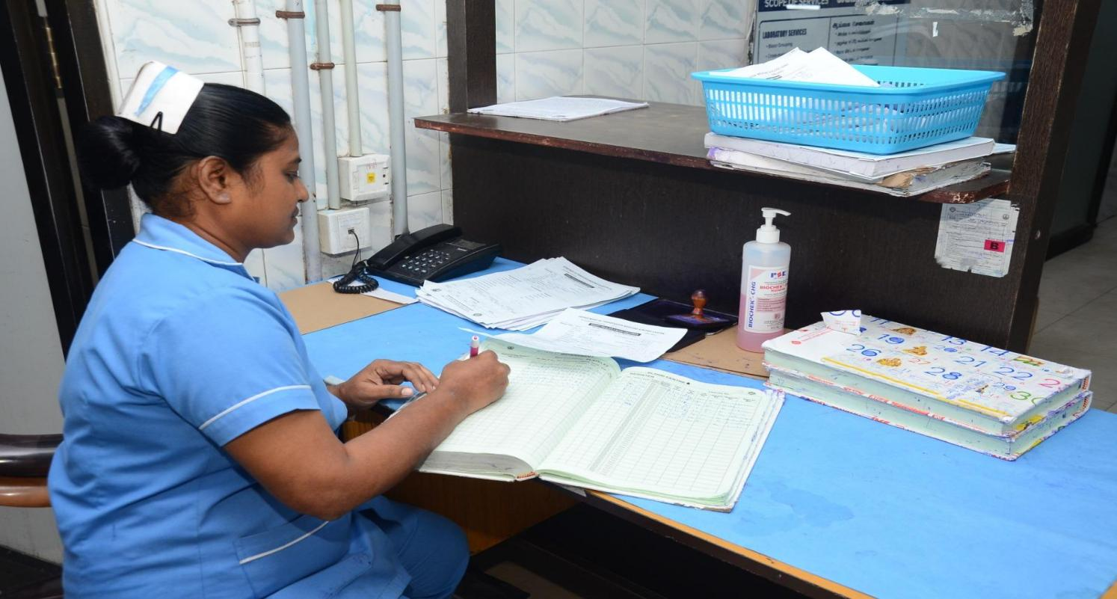

**AUTOMATED COAGULATION WORKUP**

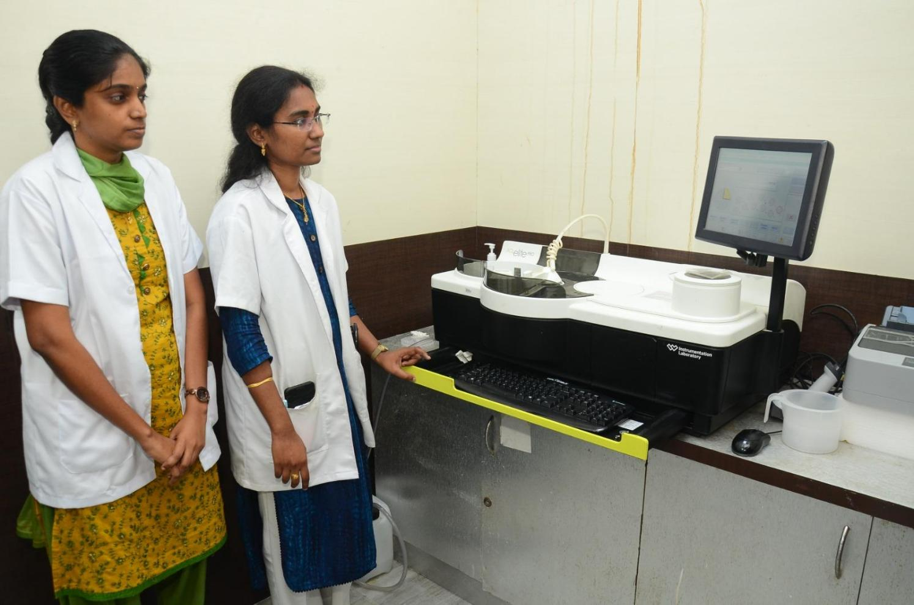

**APHERESIS DONATION**

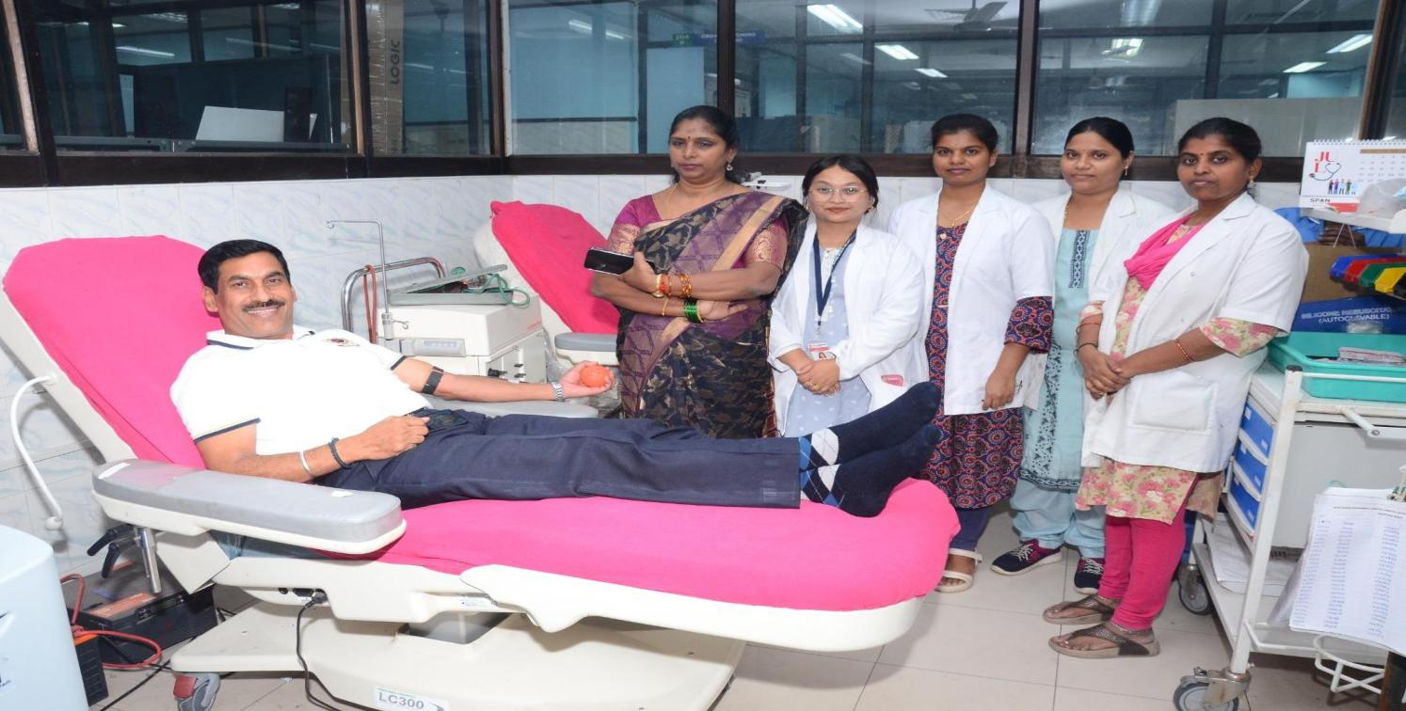

**BLOOD DONATION CAMP**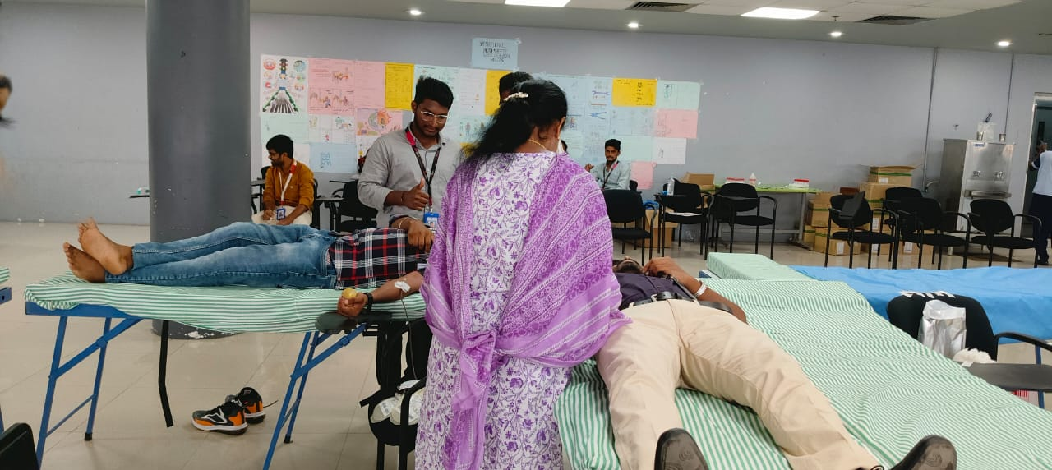

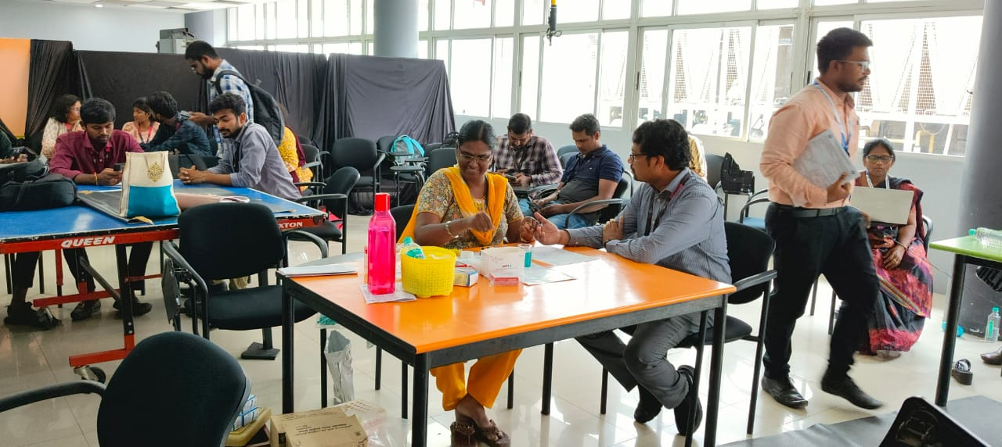

**TTI SCREENING** 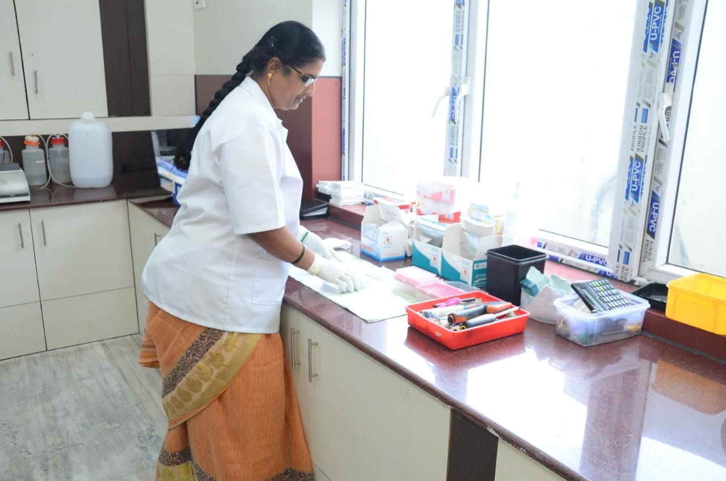

**BLOOD COMPONENT PREPARATION AREA**

